Activity sheet
Readers’ theatre and storytelling
1. Read Face the Facts – Questions and Answers about Migrants and Multiculturalism to gather facts about migration and multiculturalism. Answer the following questions:
a. What are immigrants? Who migrates to Australia?
....................................................................................................................................................
....................................................................................................................................................
....................................................................................................................................................
....................................................................................................................................................
b. Define the term ‘immigrant’. Explore the Face the Facts Glossary to gather the facts.
....................................................................................................................................................
....................................................................................................................................................
....................................................................................................................................................
....................................................................................................................................................
c. Where do migrants come from? Identify two main countries of origin during 2007/08. Explore Face the Facts – Questions and Answers about Migrants and Multiculturalism to gather some statistics to back up your answer.
....................................................................................................................................................
....................................................................................................................................................
....................................................................................................................................................
....................................................................................................................................................
2. Your teacher will provide you with a Readers’ Theatre script focussing on Herman van Haren’s story of migration from the Netherlands to Australia in 1953.
- Working in groups of seven - according to the number of characters in the story, read the script through together to gain an overall understanding of the storyline, with each member of your group taking on a character role. Discuss the script and clarify any areas of contention/confusion.
- Read the script together a second time. Focus on your specific reading sections and note any elements of characterisation – think about how you will present your character when your group performs.
- Rehearse your group performance. Decide on a minimum of props and costumes to support your performance. There is a limit of one item for each character. Remember to focus on what is important to convey meaning in the script and your character, rather than what colour you will wear! How you use your voice will be most important.
- Perform the script aloud in front of your classmates. Try to maintain eye contact with the audience and use your voice/ body to convey meaning.
3a. Discuss some of the important elements of storytelling with your classmates. Identify the important elements of various stories you have read.
....................................................................................................................................................
....................................................................................................................................................
....................................................................................................................................................
....................................................................................................................................................
....................................................................................................................................................
....................................................................................................................................................
....................................................................................................................................................
....................................................................................................................................................
....................................................................................................................................................
3b. Work with your group to adapt and present a recent real-life story of migration to Australia, either personal or based on research. After you have created your story, think about the elements and characters you have included and devise a method for presenting it to your classmates.
It could be presented as:
- Readers’ Theatre performance, where each student plays a role or series of roles
- a puppet show, where students play out the action of the story using puppets (a range of puppeting techniques could be used)
- an exhibition of old photographs or artwork which explore a story of migration to Australia
- a family history, which includes details of a story of migration to Australia.
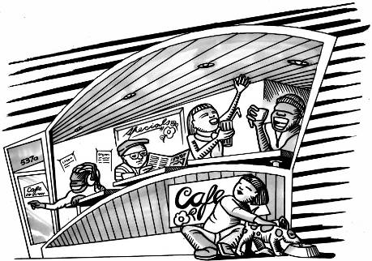
4. Discuss multiculturalism and diversity in Australia.
a) What are the impacts of immigration on Australian society? Consider:
- the main principles of the Australian Government’s policy on immigration and citizenship
- the impacts of migration in Australia from a range of perspectives including economic, social and environmental
- citizenship rates for overseas-born people resident in Australia. Use the information included in Face the Facts – Questions and Answers about Migrants and Multiculturalism to inform your discussion.
....................................................................................................................................................
....................................................................................................................................................
....................................................................................................................................................
....................................................................................................................................................
....................................................................................................................................................
....................................................................................................................................................
....................................................................................................................................................
....................................................................................................................................................
....................................................................................................................................................
....................................................................................................................................................
b) Identify three positive ways in which multiculturalism has influenced your community, at a school, local or national level.
....................................................................................................................................................
....................................................................................................................................................
....................................................................................................................................................
....................................................................................................................................................
....................................................................................................................................................
....................................................................................................................................................
....................................................................................................................................................
....................................................................................................................................................
....................................................................................................................................................
....................................................................................................................................................

